Design and Development of a Web Application for Online Group Study



*A Project Report*

*Submitted to the Department of Computer Science and Engineering, University of Rajshahi for the partial fulfillment of the requirements for the degree of*

*B.Sc Engineering in Computer Science & Engineering*

SUBMITTED BY

### Id: 1710676107

Session: 2016-17

Course code: CSE 4292

Department of Computer Science and Engineering

University of Rajshahi

Rajshahi 6205, Bangladesh

**Dedicated To**

**Honorable My Parents**

**&**

**Honorable Teacher**

**Acknowledgement**

First, I thank the Almighty God who has given me the strength and patience to complete the project. Secondly, I express my warm thanks to my project Supervisor Mr. Sanjoy Kumar Chakravarty, Assistant Professor, Department of Computer Science and Engineering, University of Rajshahi for his assistance, constant guidance, advice, encouragement, and every possible help in the preparation of this manuscript.

I also would like to thank to all of my respectable teachers of the Department of Computer Science and Engineering, University of Rajshahi for their valuable suggestion and academic helps during the course work.

**The Author**

**Abstract**

The purpose of this project is to design and development of a web application for online group study. An online group study is a website dedicated for students. In this website students can take their job preparation likes (BCS, Bank etc.) and also can take their academic preparation. At first, someone will create a group and anyone can send a request to join the group. The group admin will approve the join request according to the group motive. The admin will select a topics and date of the exam. Every member of the group can create questions (MCQ) and everyone can give exam on everyone questions. After completion of the exam, they can see their result.

**CONTENT**

**Chapter-1: Introduction ------------------------------------------------------------------ 1-2**

1.1 Introduction --------------------------------------------------------------------------------------------- 1

1.2 Scope of the Project ----------------------------------------------------------------------------------- 1

1.3 Purpose of the Project -------------------------------------------------------------------------------- 2

**Chapter-2: System Development Tools ---------------------------------------------- 3-8**

# 2.1 Required Tools and Technologies ----------------------------------------------------------------- 3

2.2.1 Operating System ------------------------------------------------------------------------------- 3

2.2.2 Apache web server ----------------------------------------------------------------------------- 4

2.2.3 PHP Server Side Script ------------------------------------------------------------------------- 4

2.2.4 MySQL relational Database ------------------------------------------------------------------ 5

2.2.5 HTML (Hypertext Markup Language) ------------------------------------------------------ 5

2.2.6 CSS (Cascading Style Sheet) ------------------------------------------------------------------ 6

2.2.7 JavaScript ----------------------------------------------------------------------------------------- 6

2.2.8 Frameworks -------------------------------------------------------------------------------------- 6

2.2.9 Database ------------------------------------------------------------------------------------------ 7

2.2.10 Laravel 8.4 -------------------------------------------------------------------------------------- 7

2.2.11 Font Awesome --------------------------------------------------------------------------------- 7

2.2.12 Livewire ----------------------------------------------------------------------------------------- 7

2.2.13 Sweet-alert ------------------------------------------------------------------------------------- 8

2.2.14 Visual Studio Code----------------------------------------------------------------------------- 8

**Chapter-3: Requirement Analysis -------------------------------------------------- 9-10**

3.1 Functional Requirements --------------------------------------------------------------------------- 9

3.1.1 User ----------------------------------------------------------------------------------------------- 9

3.1.2 Group Admin ----------------------------------------------------------------------------------- 9

3.2 Hardware Requirements -------------------------------------------------------------------------- 9

3.3 Software Requirements --------------------------------------------------------------------------- 10

3.4 Project Planning ------------------------------------------------------------------------------------- 10

3.4.1 Project Plan ------------------------------------------------------------------------------------ 10

**Chapter-4: System and Database Design -------------------------------------- 11-15**

4.1 System Design -------------------------------------------------------------------------------------- 11

4.1 Functional Diagram of the System ------------------------------------------------------------ 11

4.2 Entity Relationship Diagram -------------------------------------------------------------------- 12

4.3 Database Design --------------------------------------------------------------------------------- 13-15

**Chapter-5: Result and Discussion ------------------------------------------------ 17-29**

5.2 Outputs --------------------------------------------------------------------------------------------- 17-29

**Chapter-6: Software Testing --------------------------------------------------------- 30**

6.1 Testability ------------------------------------------------------------------------------------------- 30

6.2 Attributes of Good Test ------------------------------------------------------------------------- 30

6.3 Testing Plan ---------------------------------------------------------------------------------------- 30

**Chapter-7: Limitation and Future Scope ------------------------------------------ 31**

7.1 Limitations ------------------------------------------------------------------------------------------- 31

7.2 Future Scope ---------------------------------------------------------------------------------------- 31

**Chapter-8: Conclusion ----------------------------------------------------------------- 32**

8.1 Conclusion ------------------------------------------------------------------------------------------- 32

**References ------------------------------------------------------------------------------- 33**

Chapter 1

***Introduction***

* 1. **Introduction**

Students form a group consisting of 4-5 members in the universities and colleges. These groups usually focus on academic subjects. However, most of these groups have job preparation (such as BCS, Bank etc.). During group discussions, they determine a topic, discuss it, and give an exam on a specific topic at a specific date and time. All the group members create the exam questions (Limited), and everyone can answer everyone's questions and count the marks.

But because of covid-19, everyone had to stay at home. As a result, no one could do group activities physically. And since everything is digital, students also want to do group study sitting at home or any place via online.

**1.2 Scope of the Project**

The features of this web application are: user can create group (who will be admin), if someone wants to join this group he/she will request to join the group, if admin or group members allow him then admin will be approved request, group members can communicate among themselves, can post, can share different files.

Everyone can create and upload questions and cannot see each other's questions before the specified time of the exam (MCQ type). After submitting the answer, the mark will be counted, and the examinee's position will be shown.

**1.3 Purpose of the Project**

* Study groups can help students develop as students, people, and professionals.
* It can help students learn course material deeper and more concrete. But due to covide-19 people can't gather together physically. Due to this, the main goal of the group study has been affected. So students can easily do group study on online
* Those who want to prepare for the job at the end of their studies do not want to physically attend the group study because they do not want to waste time on travel. So online is better for them.
* If students want to group study, then online group study is better.

Chapter 2

***System Development Tools***

# **2.1 Required Tools and Technologies**

Now the time has come to pick up system (operating system) and technologies needed to implement the project. I have selected these things depending on their availability and resources needed studying them. I have chosen the following system and technologies.

1. Operating System
2. Apache web server
3. PHP
4. MySQL relational Database
5. HTML (Hypertext markup language)
6. CSS (Cascading Style Sheet)
7. JavaScript
8. Front-end frameworks: Bootstrap, Jquery
9. Back-end framework: Laravel 8.x
10. Font Awesome
11. Livewire(Full=stack framework for Laravel)
12. Sweet-alert
13. visual studio code

# **2.2.1 Operating System**

Any kind of operating systems can be used for this project, because server and programming language I have used can be run at any OS. But I have used Windows OS (10 pro) for implement my project. This OS is better availability and I operate this OS easily. It’s graphical interface so much user friendly that I think.

# **2.2.2 Apache web server**

The **Apache HTTP Server**, colloquially called Apache is a free and open-source cross-platform web server, released under the terms of Apache License 2.0. This server serve more than 100 million websites.

Apache web server is developed and managed by an open community of developers. They are under the auspices of the Apache Software Foundation. On Unix-like System is used for this software. Those OS are Unix FreeBSE, Linux, Solaris, Novell NetWare, OS X, Microsoft Windows, OS/2, TPF and eComStation. Apace is open source software.[1]

# **2.2.3 PHP Server Side Script**

PHP is a programming language devised by Rasmus Lerdorf in 1994 for building dynamic, interactive web stories. It is a server-side scripting language designed for Web development, but also used as a general-purpose programming language. PHP code may be embedded into HTML code, or it can be used in combination with various web template systems, web content management systems, and web frameworks. PHP code is usually processed by PHP interpreter implemented as a module in the web server or as a Common Gateway Interface (CGI) executable. The web server combines the results of the generated web page. PHP code may also be executed with a command-line interface (CLI) and can be used to implement standalone graphical applications. [8]PHP 7.3.2 version is used here.

**Areas on PHP:**

There are three main areas where PHP scripts are used.

1. Server-side scripting: This is the most traditional and main target field for PHP. Three things need to make this work. The parser, a web server and a web browser.
2. Command Line Scripting: We can make a PHP Script to run it without any server or browser. We only needs the parser to use in this way.
3. Writing Desktop Applications: PHP is not probably the very best language to create a desktop application with a graphical user interface, but if we know PHP very well, would like to use advance PHP.

# **2.2.4 MySQL relational Database**

MySQL is the world’s most widely used open source relational database management system (RDBMS) that runs as a server providing multi-user access to a number of databases, through SQLite probably has more total embedded deployments. It is named after co-founder Michael Widenius’s daughter, MySQL phrase stands for Structured Query Language.

The MySQL development project has made its source code available under the terms of the GNU General Public License, as well as under a variety of proprietary agreements.

**Basic operation of MySQL:**

* Create Table
* Insert records
* Load data
* Retrieve records
* Update records
* Delete records
* Modify table
* Join Table
* Drop Table
* Optimize table
* Count, Like, Order by, Group by
* More advanced ones (sub-queries, stored procedures, triggers, views…)

# **2.2.5 HTML (Hypertext Markup Language)**

Hypertext Markup Language (HTML) is the standard markup language for creating web pages and web applications.

HTML is written in the form of HTML elements consisting of tags enclosed in angle brackets within the web page content. HTML tags most commonly come in pairs like <h1> and </h1>, although some tags and the second tag is the end tag. In between these tags web designers can add text, further tags, comments and other types of text-based content.

**Features of HTML5:**

* It is very easy and simple language. It can be easily understood and modified.
* It facilitates the programmer to add Graphics, Videos, and Sound to the web pages which makes it more attractive and interactive.
* It is platform-independent because it can displayed on any platform like Windows, Linux and Macintosh etc.

.

# **2.2.6 CSS (Cascading Style Sheet)**

CSS is a style sheet language used for describing the presentation semantics of a document written in markup language like HTML. CSS is a cornerstone technology of the World Wide Web, alongside HTML and JavaScript.

CSS is designed primarily to enable the separation of document from document presentation, including elements such as the layout, colors and fonts. This separation can improve content accessibility, provide more flexibility and control in the specification of presentation characteristics, enable multiple pages to share formatting and reduce complexity and repetition in the structural content CSS can also allow the same markup page to be presented in different styles for different rendering methods, such as on-screen, in print, by voice and on Braille-based, tactile devices.

# **2.2.7 JavaScript**

JavaScript is a lightweight, interpreted programming language. It is designed for creating network-centric applications. It is complimentary to and integrated with java. JavaScript is very easy to implement because it is integrated with HTML. It is open and cross-platform.

JavaScript’s use in applications outside of web pages for example, in PDF documents, site-specific browsers and desktop widgets is also significant. Newer and faster JavaScript for server-side web applications.

# **2.2.8 Frameworks**

**Bootstrap:**

Bootstrap is a free collection of tools for creating websites and web applications. It contains HTML and CSS-based design templates for typography, forms, buttons, navigation and other interface component, as well as optional JavaScript extension.

**JQuery:**

JQuery is free, open source software, licensed under the MIT license. JQuery’s syntax is designed to make it easier to navigate a document, select DOM elements, create animations, handle event and develop Ajax applications. JQuery also provides capabilities for developers create plug-ins on top of the JavaScript library. JQuery is a multi-browser JavaScript Library designed to simplify the client-side scripting of HTML.

# **2.2.9 Database**

* A Lightweight database management system connection abstract library.
* Extension of a PHP5 is written in a compiled language.
* It support huge number of database system.
* We cannot rewriting of many line code of DB.
* Easy to install.
* We don’t need third party.

# **2.2.10 Laravel 8.x**

Laravel 8 is a free open-source PHP web framework, created by Taylor Otwell and intended for the development of web applications following the model-view-controller (MVC) architectural pattern and based on Symfony. Some of the features of Laravel are a modular packaging system with a dedicated dependency manager, different ways for accessing relational databases, utilities that aid in application deployment and maintenance, and its orientation toward syntactic.

# **2.2.11 Font Awesome**

Font Awesome is a font that's made up of symbols, icons, or pictograms that you can use in a webpage, just like a font. Font Awesome is well, awesome! It's a great icon based font that's very commonly paired-up with Bootstrap-based web projects. It has a library of 369 icons larger than the 200 native Bootstrap 3 glypicons and can also unlock unique features like flipped, stacked or rotated icons

# **2.2.12 Livewire (Full=stack framework for Laravel)**

Livewire is a full-stack framework for Laravel that makes building dynamic interfaces simple, without leaving the comfort of Laravel. The goal of actions in Livewire is to be able to easily listen to page interactions, and call a method on your Livewire component (re-rendering the component). Livewire currently offers a handful of directives to make listening to browser events trivial.

# **2.2.13 Sweet-alert**

Laravel Sweet Alert - Alert is a notification area that usually contains short messages such as success, error, warning, info and others. In some uses, alerts are usually used for confirmation dialogs with yes or no actions, such as using the delete feature, there will be a kind of confirmation dialog

# **2.2.14 Visual Studio Code**

Visual Studio Code is a streamlined code editor with support for development operations like debugging, task running, and version control. It aims to provide just the tools a developer needs for a quick code-build-debug cycle and leaves more complex workflows to fuller featured IDEs, such as Visual Studio IDE

Chapter 3

***Requirement Analysis and Planning***

**3.1 Functional Requirements**

In this section we will briefly discuss different functional requirements.

**3.1.1 User**

1. User registration system.

2. Log in and update profile.

3. Choose group or can create new group.

4. Will be able to create question and give exam.

5. View result.

6. Must be flow the group rules

**3.1.2 Group Admin**

1. Add new member.

2. Add topics.

3. Give exam schedule.

**3.2 Hardware Requirements**

* **Processor:** I GHZ(x64 or X86)
* **Speed:** Minimum 1.4 GHz
* **RAM:** Minimum 1 GB
* **Hard Disk:** 20 GB and above
* **Keyboard:** Standard
* **Mouse:** Standard

**3.3 Software Requirements**

* **Operating System:** Windows 7, 8, 8.1, Windows 10
* **Browser:** Mozilla Firefox, Chrome, Internet Explorer
* **Front End:** PHP 5, Laravel 8.x, JQuery, HTML, CSS, Bootstrap
* **Back End :** MySql, Apache
* **Text Editor:** Visual Studio Code

**3.4 Project Planning**

Project planning includes description of the project task, activity and function, dependencies, resource requirements and detail schedules. Project planning involves estimating how much time, efforts, money and resources will be required to build a specific software system

**3.4.1 Project Plan**

Before proceeding with the development of the project, it is inevitable to plan its development right from the start till the end.

|  |  |  |
| --- | --- | --- |
| **Task** | **From Date** | **To Date** |
| Requirement analysis | 12 –November-2021 | 27 –November-2021 |
| Design | 12 – December-2021 | 15 –January- 2022 |
| Coding | 16– January- 2022 | 30 – march- 2022 |
| Testing and debugging | 31 – March- 2022 | 12 – April- 2022 |

Table 3.4.1: Project Plan

Chapter 4

***System and Database Design***

**4.1 System Design**

System design is the process or art of defining the architecture, components, modules, interfaces, and data for a system to satisfy specified requirements. Object Oriented Analysis and Design (OOAD) methods are becoming the most widely used methods for computer system design.

**4.2** **Functional Diagram of the System**

Add Member

Create Topic

Start Exam

Admin

Question Upload

Give Exam

View Result

Group

Question Upload

Give Exam

View Result

Sign In/UP

Member

User

Fig 4.2: Functional Diagram of the system

**4.2 Entity Relationship Diagram**

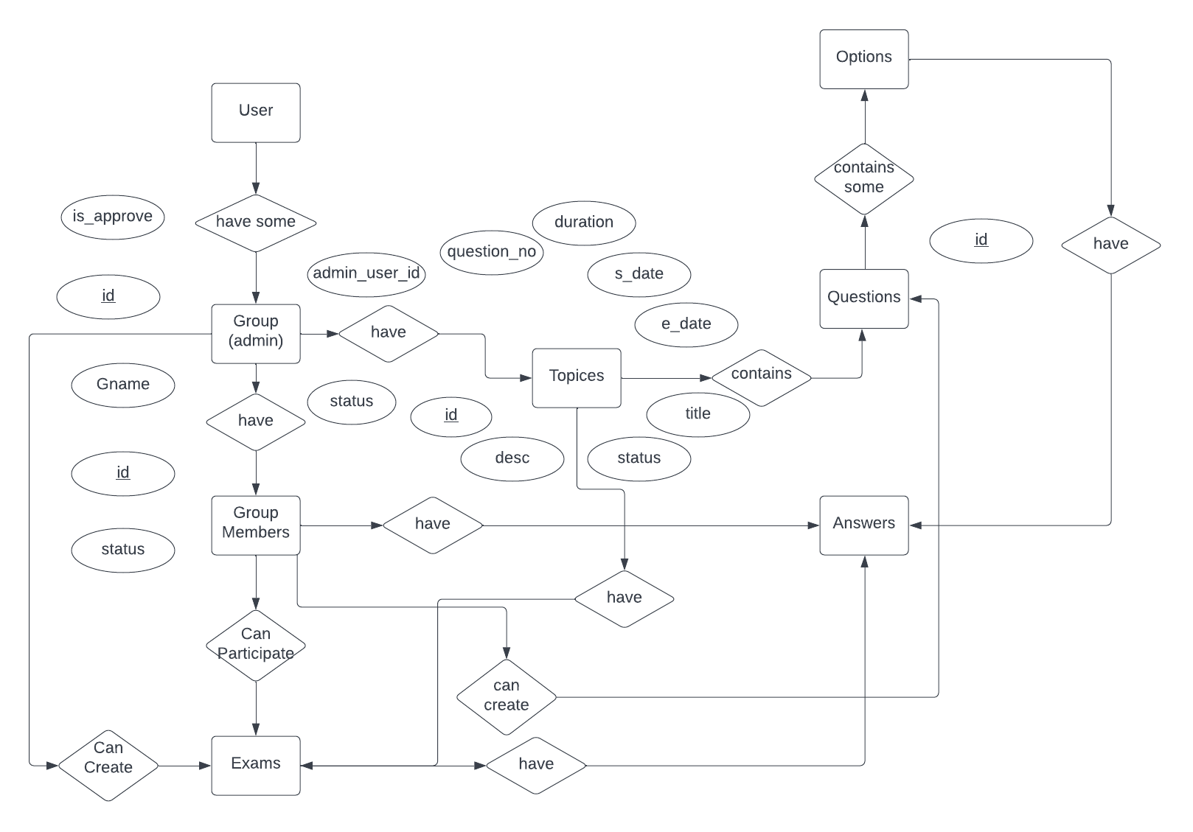

Fig 4.3: EntityRelationship Diagram

**4.5 Database Design**

Database is a collection of data that can be treated as single unit. The single or individual unit is called table. In relational database system Table is a combination of rows and columns which show records and fields respectively.

Determining all the entities we design the table structure as follows:

**Table 1: users**

|  |  |  |  |  |
| --- | --- | --- | --- | --- |
| **S.R** | **Field Name** | **Data Type** | **Size** | **Validation** |
| 1. | Id | Integer | 10 | Primary key |
| 2. | Name | Varchar | 191 |  |
| 3. | Fname | Varchar | 191 |  |
| 4. | Lname | Varchar | 191 |  |
| 5. | Email | Varchar | 191 |  |
| 6. | Password | Varchar | 191 |  |
| 7. | Created_at | Timestamp |  |  |
| 8. | Updated_at | Timestamp |  |  |

**Table 2: Create Groups**

|  |  |  |  |  |
| --- | --- | --- | --- | --- |
| **S.R** | **Field Name** | **Data Type** | **Size** | **Validation** |
| 1. | Id | Integer | 10 | Primary key |
| 2. | User_id | Integer | 11 | Foreign key |
| 3. | Gname | Varchar | 255 |  |
| 4. | Is_approve | Integer | 11 |  |
| 5. | Admin_user_id | Integer | 11 |  |
| 6. | Status | Integer | 11 |  |
| 7. | Created_at | Timestamp |  |  |
| 8. | Updated_at | Timestamp |  |  |

**Table 3: Group Members**

|  |  |  |  |  |
| --- | --- | --- | --- | --- |
| **S.R** | **Field Name** | **Data Type** | **Size** | **Validation** |
| 1. | Id | Integer | 10 | Primary key |
| 2. | Group_id | Integer | 11 | Foreign key |
| 3. | User_id | Integer | 11 | Foreign key |
| 4. | Status | Integer | 11 |  |
| 5. | Created_at | timestamp |  |  |
| 6. | Updated_at | timestamp |  |  |

**Table 4: Topics**

|  |  |  |  |  |
| --- | --- | --- | --- | --- |
| **S.R** | **Field Name** | **Data Type** | **Size** | **Validation** |
| 1. | Id | Integer | 10 | Primary key |
| 2. | User_id | Integer | 11 | Foreign key |
| 3. | Group_member_id | Integer | 11 | Foreign key |
| 4. | Question_no | Integer | 11 |  |
| 5. | Duration | Decimal | 12,2 |  |
| 6. | Start_date | Date |  |  |
| 7. | End_date | Date |  |  |
| 8. | Title | Text | 255 |  |
| 9. | Description | Text | 1000 |  |
| 10. | Exam_start_date | DateTime |  |  |
| 11. | Exam_end_date | DateTime |  |  |
| 12. | Status | Integer |  |  |
| 13. | Created_at | Timestamp |  |  |
| 14. | Updated_at | Timestamp |  |  |

**Table 5: Create Question**

|  |  |  |  |  |
| --- | --- | --- | --- | --- |
| **S.R** | **Field Name** | **Data Type** | **Size** | **Validation** |
| 1. | Id | Integer | 10 | Primary key |
| 2. | Topic_id | Integer | 11 | Foreign key |
| 3. | Group_member_id | Integer | 11 | Foreign key |
| 4. | User_id | Integer | 11 | Foreign key |
| 5. | Question | Varchar | 255 |  |
| 18. | Created_at | Timestamp |  |  |
| 19. | Updated_at | Timestamp |  |  |

**Table 6: Options**

|  |  |  |  |  |
| --- | --- | --- | --- | --- |
| **S.R** | **Field Name** | **Data Type** | **Size** | **Validation** |
| 1. | Id | Integer | 10 | Primary key |
| 2. | Question_id | Integer | 11 | Foreign key |
| 3. | Option | Varchar | 255 |  |
| 4. | Is_answer | Integer | 11 |  |
| 5. | Created_at | Timestamp |  |  |
| 6. | Updated_at | Timestamp |  |  |

**Table 7: Exams**

|  |  |  |  |  |
| --- | --- | --- | --- | --- |
| **S.R** | **Field Name** | **Data Type** | **Size** | **Validation** |
| 1. | Id | Integer | 10 | Primary key |
| 2. | Topic_id | Integer | 11 | Foreign key |
| 3. | User_id | Integer | 11 | Foreign key |
| 4. | Exam_start_date | DateTime |  |  |
| 5. | Exam_end_date | DateTime |  |  |
| 6. | Created_at | Timestamp |  |  |
| 7. | Updated_at | Timestamp |  |  |

**Table 8: Answers**

|  |  |  |  |  |
| --- | --- | --- | --- | --- |
| **S.R** | **Field Name** | **Data Type** | **Size** | **Validation** |
| 1. | Id | Integer | 10 | Primary key |
| 2. | Question_id | Integer | 11 | Foreign key |
| 3. | Option_id | Integer | 11 | Foreign key |
| 4. | User_id | Integer | 11 | Foreign key |
| 5. | Exam_id | Integer | 11 | Foreign key |
| 6. | Created_at | Timestamp |  |  |
| 7. | Updated_at | Timestamp |  |  |

Chapter 5

***Result and Discussion***

5.1 **Outputs**

**Group Study Homepage:**

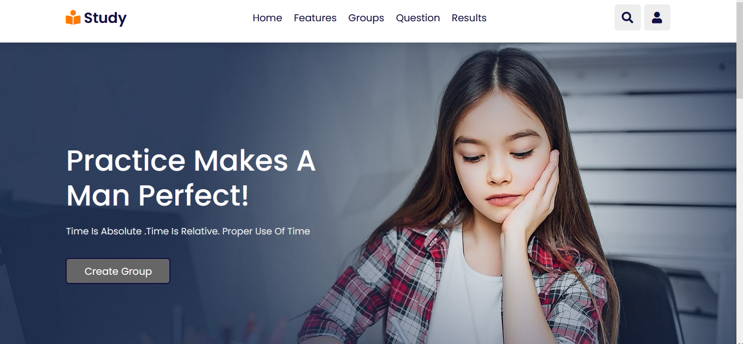

**Our features:**

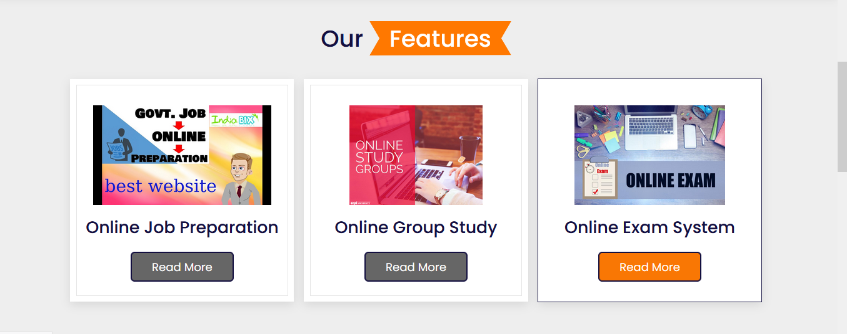

**User Log In:**

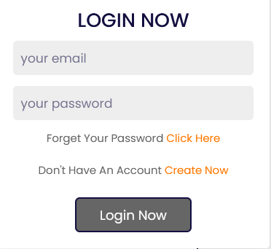

**User Sign Up:**

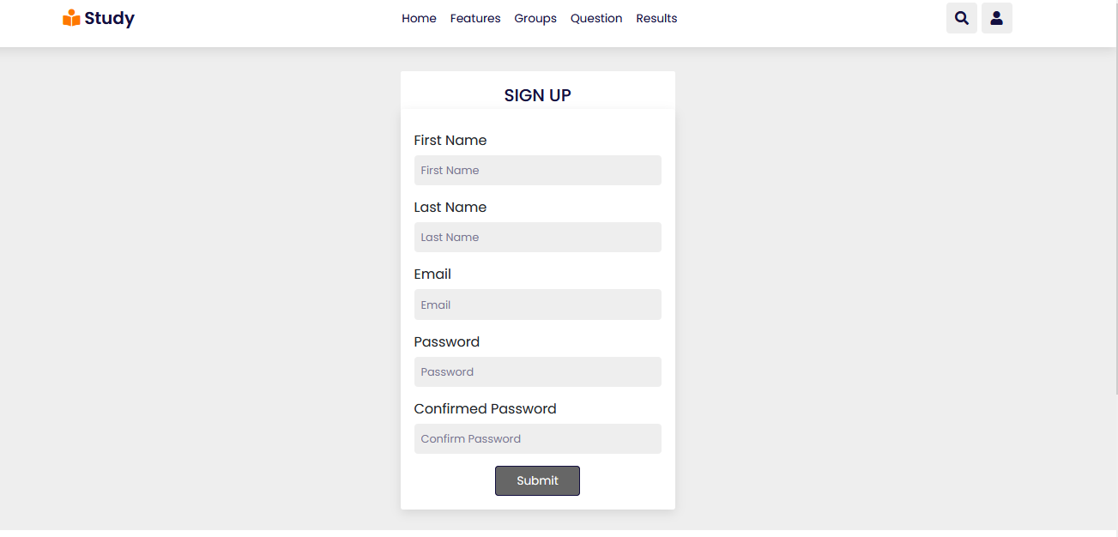

**User Profile:**

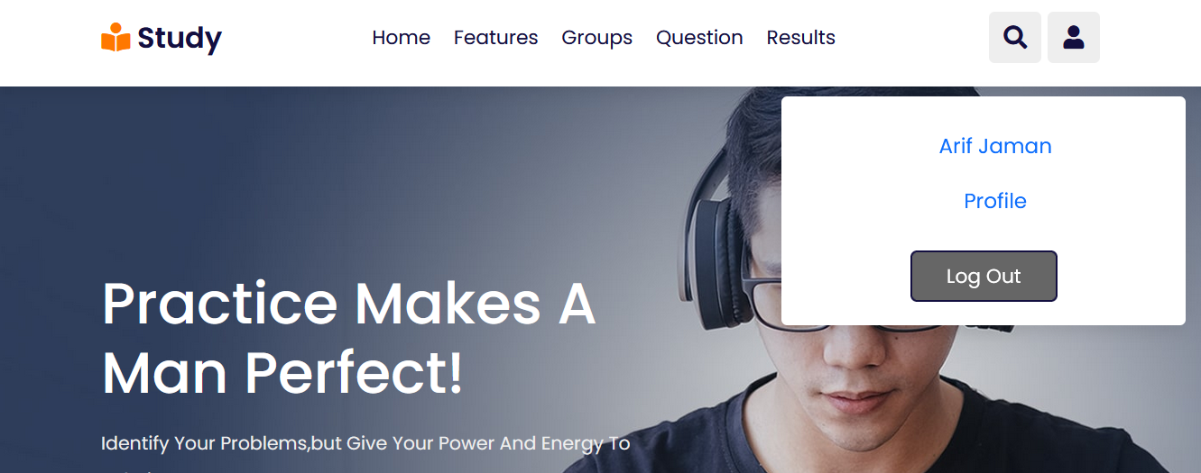

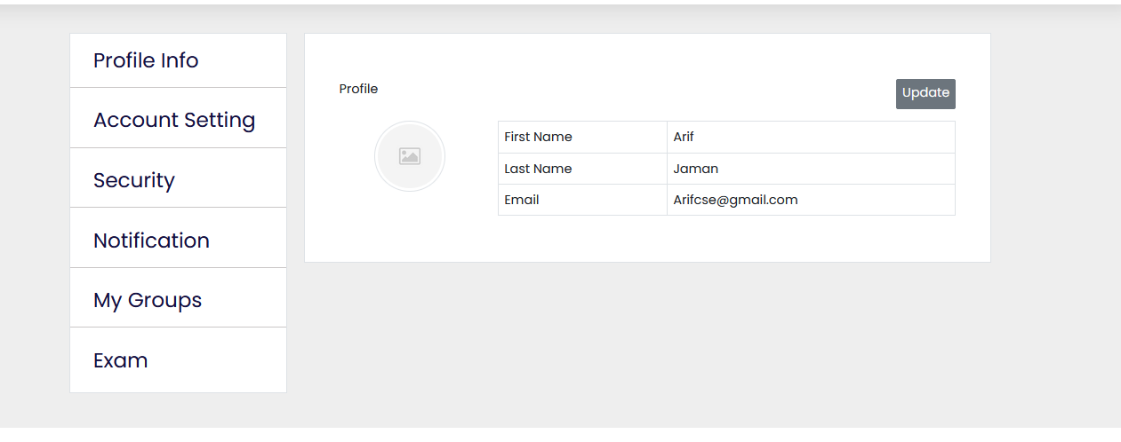

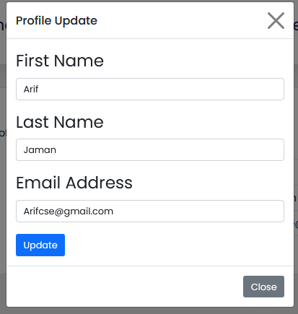

**Create New group Option:**

Who create the group will be the admin of the group



**Group Name From:**

**Group Show:**



**Join Group Option:**

If anoyone want to join the existing group need click join group and then the join request will be pending.



**My Groups:**

Who joined a group the join request will be see pending before approved by admin

**User Profile:**

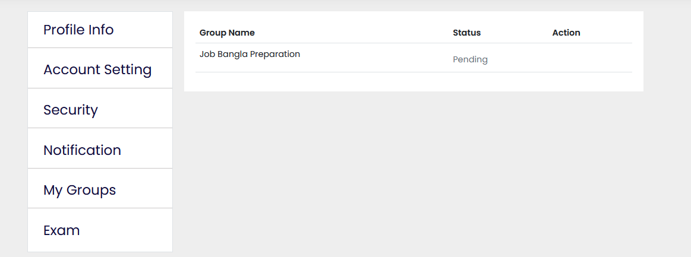The user will not show anything of the group activity until admin approved the join request

**View Group:**

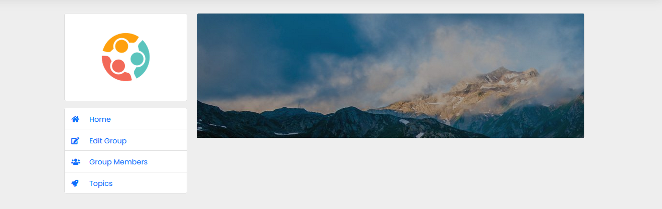

**Group Member**:

Admin Profile

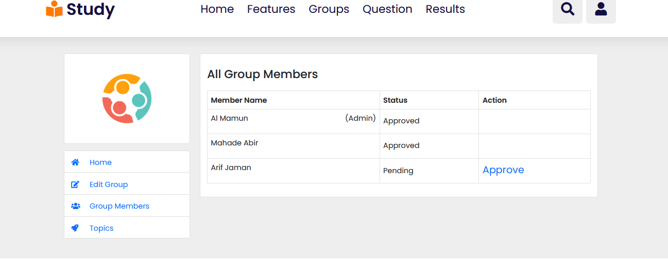

**Admin activity:**

Only admin can approve join member request:

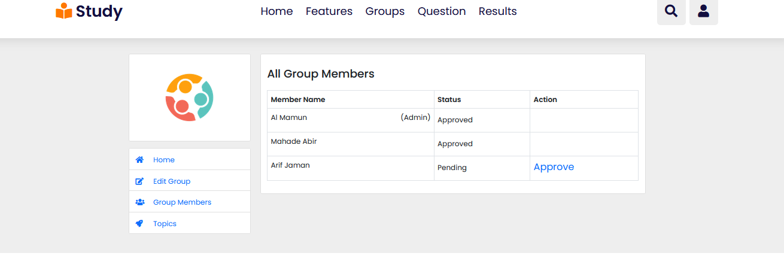

**After Approved member:**

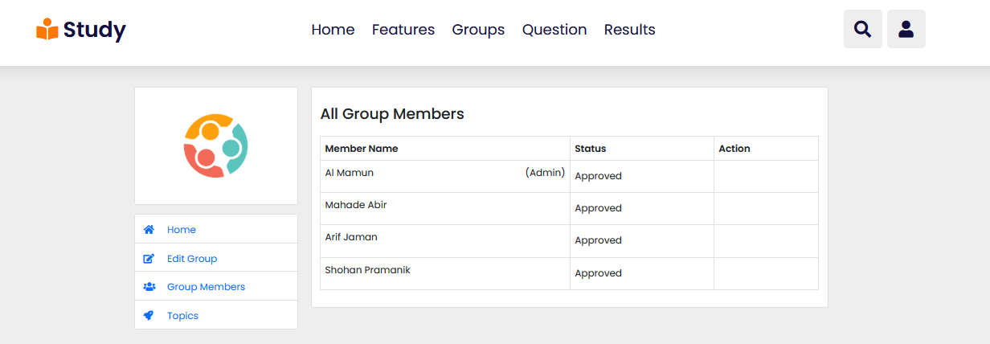

**Topics:**

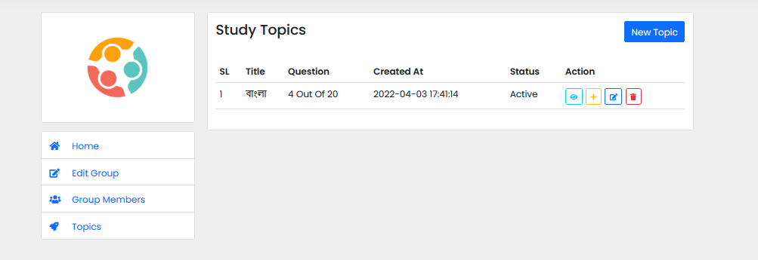

**Only admin can create new topics:**

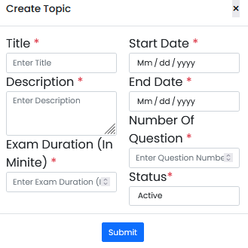

**Edit topics:**

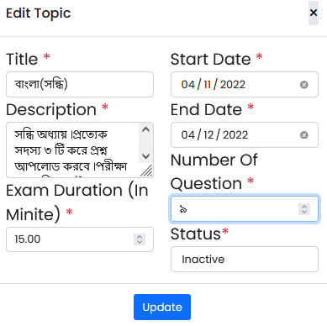

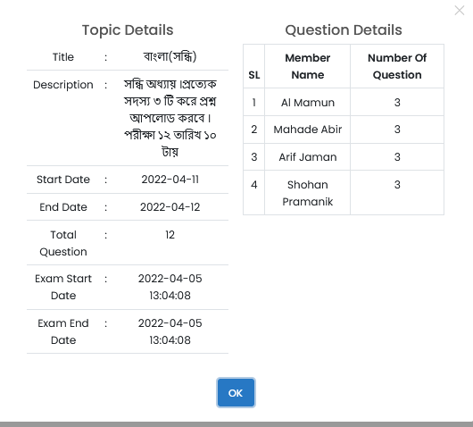

**Icon details:**

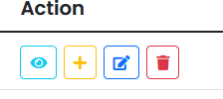

1. View

2. Add question option

3. Edit topics (only admin can do it)

4. Delete topics (only admin can do it)

**Question Add:**

Admin:

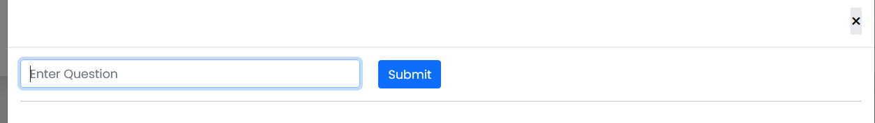

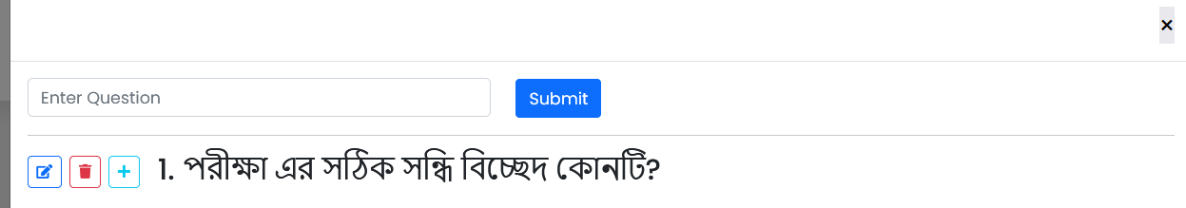

**Icon details:**

1. Edit question

2. Delete Question

3. Add option

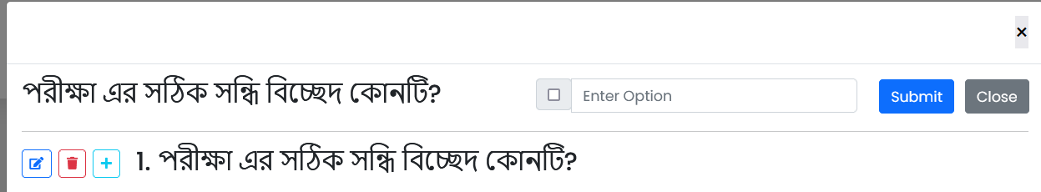

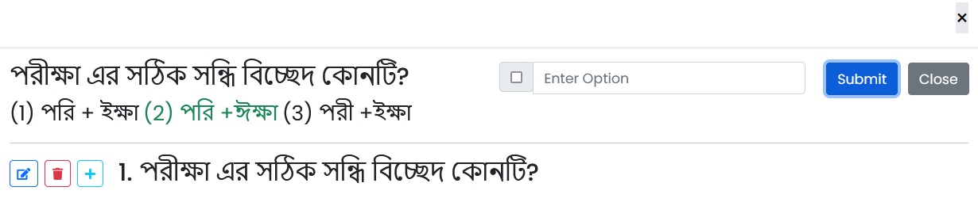

**Add more Question:**

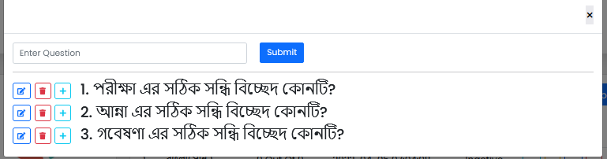

**Group member add question:**

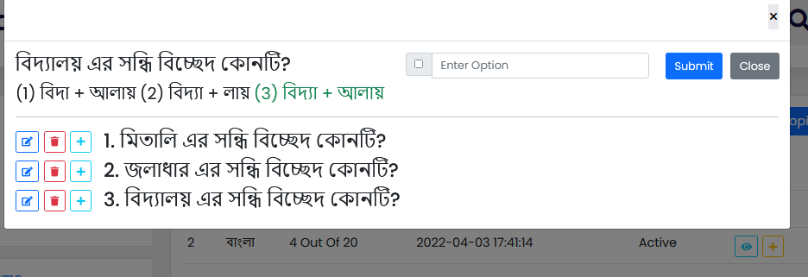

**After add question all member:**

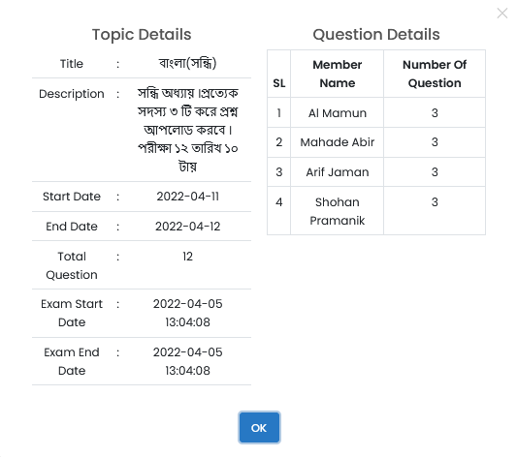

**Status:**

If status is inactive one member can’t view another member question and exam will not be start

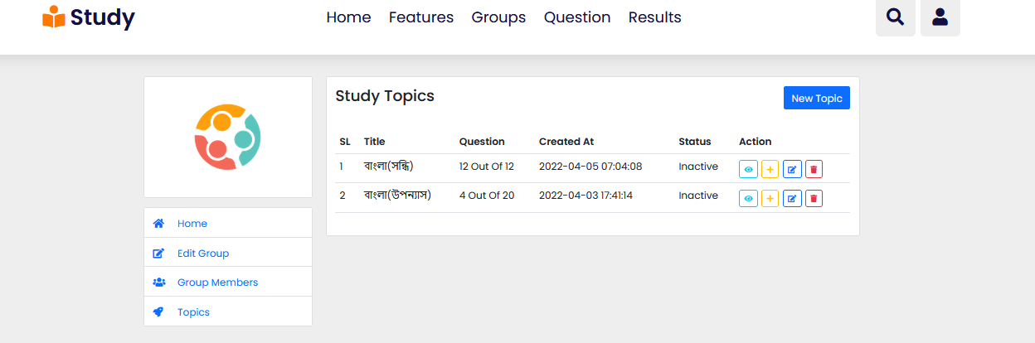

**Exam not started:**

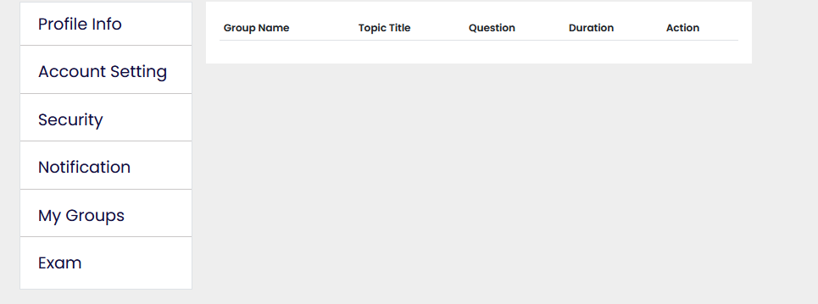

**Admin active the status:**

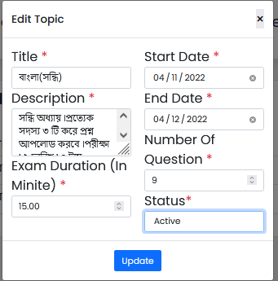

**Exam will be start now:**

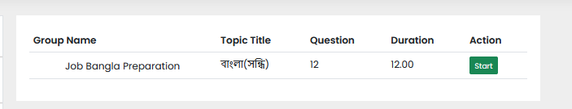

**Time will be counted:**

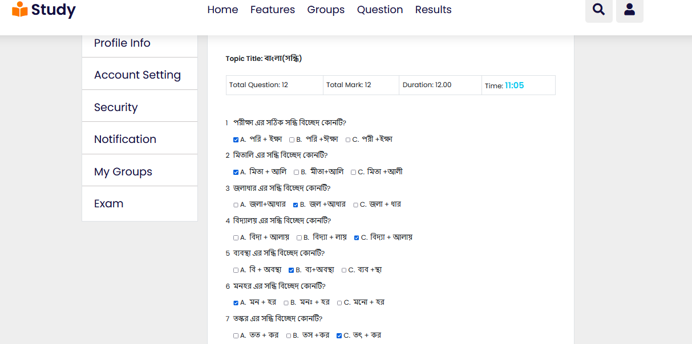

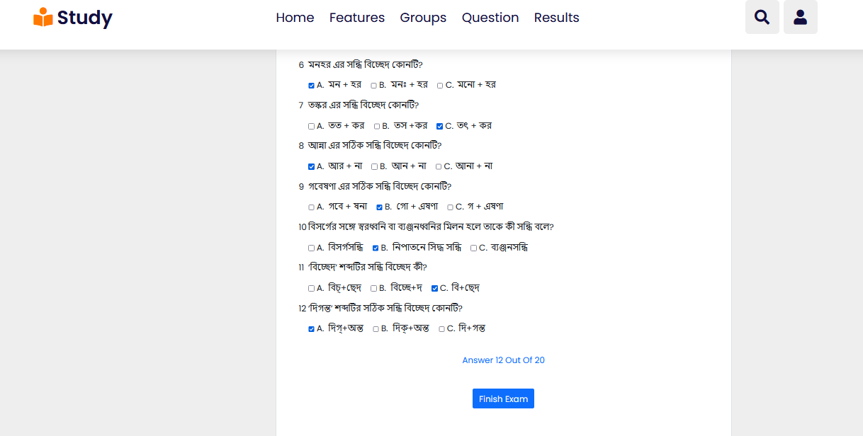

**Result Show:**

Aafter finished exam they can see their result

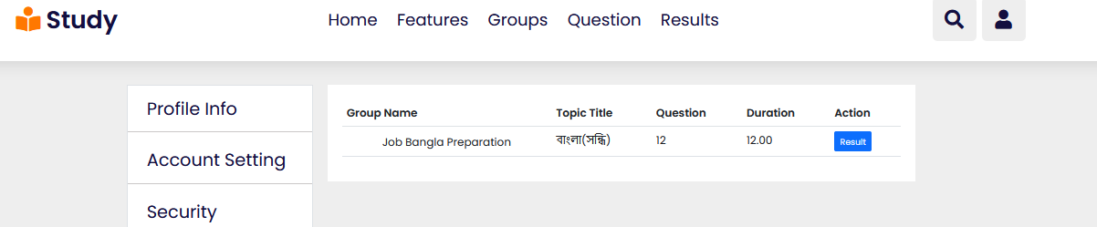

**Correct and Wrong Answer:**

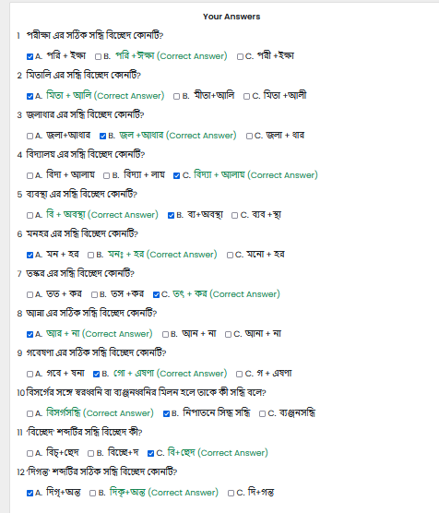

Chapter 6

***Software Testing***

**6.1 Testability**

* Software Testability is simply how easily a computer program can be tested. The check list that follows provides a set of characteristics that lead to testable software.
* Operability
* Observables
* Controllability
* Decomposability
* Simplicity
* Stability
* Understandability

6.2 Attributes of Good Test

* A good test has a high probability of finding an error.
* A good test is not redundant.
* A good test would be neither too simple nor too complex.

**6.3 Testing Plan**

The Testing Process

Developer tests the software process activity such as design, implementation and the requirement engineering. Because, design errors are very costly to repair when the system has been started to operate. Therefore, it is quite obvious to repair them at early stage of the system. So, analysis is the most important process of any project.

**Tested Items:**

Our tested items are like:

* Data fetching from the database
* Data insertion, updating and deletion in the database
* Form access to particular login

Chapter 7

***Limitation and Future Scope***

**7.1 Limitations**

* The site is not capable for chat service.
* The site is not capable of written exam.

**7.2 Future Scope**

* In future if I get a chance to work on the same project then I would like to implement capability for live chat service and written exam.
* I’ll try to make this site more secure.

Chapter 8

***Conclusion***

**8.1 Conclusion**

This is to conclude that the project that we undertook was worked upon with a sincere effort. This project has given me an ample opportunity to design, code, test and implements an application. This has helped in putting into practice of various Software Engineering principles and Database Management concepts like maintaining integrity and consistency of data. Most of the requirements have been fulfilled up to the mark and requirements which have been remaining, can be completed with a short extension. A well-designed Graphical User Interface (GUI) was designed carefully to make this software user friendly.

Finally I thank my guide for his invaluable contribution in guiding me throughout the project. I also thank my parents and friends who have supported and motivated me to complete this project successfully.

***REFERENCES***

1. Antonio Lopez, “Learning PHP 7”, Copyright© 2016 Packt Publishing.

2. Jeffery Zeldmann, “HTML5 for Web Designers, Fourth Edition”, Copyright© 2010 by the McGraw-Hill companies.

3. John Duckett, “JAVASCRIPT & JQUERY interactive front end web development”, copyright@ 2007 by the Mbdatt companies, Inc.

4. Thomas A. Powell, “The complete Reference HTML & XHTML, Fourth Edition”,

copyright@ 2003 by the McGraw-Hill companies.

5. Laravel Framework, “https://laravel.com/docs/8.x”, last accessed 8.04.2022.

6. LiveWire, “https://laravel-livewire.com/docs/2.x/quickstart”, last accessed 7.04.2022.

7. Bootstrap, “https://getbootstrap.com/docs/5.1/getting-started/introduction”, last accessed 5.04.2022.

8. Web Application Testing, “https://www.guru99.com/web-application-testing.html”, last accessed 13.04.2022.

9. [1] Apache HTTP Server, “https://en.wikipedia.org/wiki/Apache_HTTP_Server”, last accessed 12.04.2022.